Project Identification

Project Design

Version 2

Name
Phish – Hussaria
A combination of Phishing and the abbreviation for the polish hussars. The hussars were European warriors coming out of Poland. As a result, I believe this would create a unique application design

Style
A pastel coloured designed very mellow colours that blend in on the screen and does not stand out.

Vision

Who?
The project is to be aimed at the elderly and young people. People that are tech-illiterate and as a result need assistant. However, anyone should benefit.

Why?
The main problem I want to solve is the large amount of phishing attacks on the vulnerable. According to the NCSC [1 in 2025 they effect 93% of business that were surveyed and 95% of charities that have been targets of a phishing attack.

The Product?
The project is to scan a screen and possibly screens HTML elements of a website and identifies the suspicious links and notifies the user.
I would like to also have the app to use a Language Model to analyse the email for possible Scam messages. A few flags:
- Generic and non-direct greetings like Ma’am, Sir, Mr
- Urgently wanting to redirect you.
- Sender’s address does not match the body or domain.

Reason For?
The reason for this approach Is this that I want to create a software that act like a trusted and tech literate grandson scanning a grandparent’s device for the same reason. I want software that also teaches the user of possible dangers and make them self-reliant.

Execution
I will be creating google extension that will begin by working on Gmail but with a modular structure will be able to work with other mailing providers or even standalone. I will scan an email for links and words and produce a risk score of the emails and warn the user why that score is produced. It will not only protect them but also educate them by continuously providing reasons for the warnings.

Difference
Main part for this software is its trustworthiness. I want to create a software that has customisable intrusion settings. Based on how intrusive it will be, but less intrusive may mean less effective. However, this is a big part as it will hopefully make the user base more willing to use the software.
Secondly, I want this to be somewhat interactive where the user learns to seek the patterns the software is seeking for and hopefully learn to be independent.

Current market software

Avanan
A software that uses a cloud hosted email service. It evaluates existing relationships between senders and receivers to establish a level of trust. Additional It monitors Teams and Slack as they are emerging attack vectors.

Cofense PDR
Leverages AI tools and security professionals to identify and mitigate phishing attacks as they happen. They quarantine possible attacks. They also utilise global intelligence on what attacks worked and how to mitigate them

Mimecast
Several tools protect against phishing attempts. Such features detect suspicious links and redirects, attachments by removing them or rendering them safe via sandboxing. Mimecast prevents code-based attacks via sophisticated methods like QR-codes by opening them in the Mimecast cloud, this simplifies the deployment of their software and ensures prevention tools are always updated.

Current Market Extensions

PIXM phishing Protection
Uses AI to scan webpage for Logos and verifies if page is or is not owned by the stated website.
URL:
https://chromewebstore.google.com/detail/pixm-phishing-protection/flomofhkchlalfciiibgbfcpolhmglai

Anti Phishing
Warns when accessing blacklisted websites

https://chromewebstore.google.com/detail/anti-phishing/npipcajipdkafdkellochifbfmppdalo

Criminal IP: AI-based Phishing Link Checker
Checks a link is malicious using who is and blocks access.
https://chromewebstore.google.com/detail/criminal-ip-ai-based-phis/dhkbjdnlhahnffncheehbnoaecncdpdk

Mascots
Beneficial for user engagement and the app perception. I will need to create a mascot that will represent the apps core values and will be easy to identify at a glance.

Clippit

A windows 97 Icon and mascot. Was designed to offer tips, provide shortcuts, and suggestions while user worked in office applications. Was a simple natural language processor to interpret user actions and provided context-based assistance.


BonziBuddy
BonziBuddy was a desktop assistant that could tell jokes, talk and sing songs. It aimed to make using the computer more fun by providing web browsing help. The program used text-to-speech technology for this.

My Response = Hussar

This is a hussar soldier with core values of Vigilance, Protection, Trustworthiness and Precision. The history is a good fit for what the app is to perform. The image was not created by me by generated by AI.

Project Planning

Agile
I will be utilising a fortnightly recurring agile sprint plan where I will have an object, execute the object then test the outcome and review if the outcome is a sufficient solution to the objective. This will allow me to perform recurring and fast patches of any new software implemented and it will ensure that sub section is complete before moving on. My main benefit of this style is that it will help reduce issues in the project lifecycle with incomplete software. In the case that I am unable to perform a section in the time allocated I will perform a risk assessment and if the software needs to be complete before moving as it will cause issues, I will delay the next sprint.
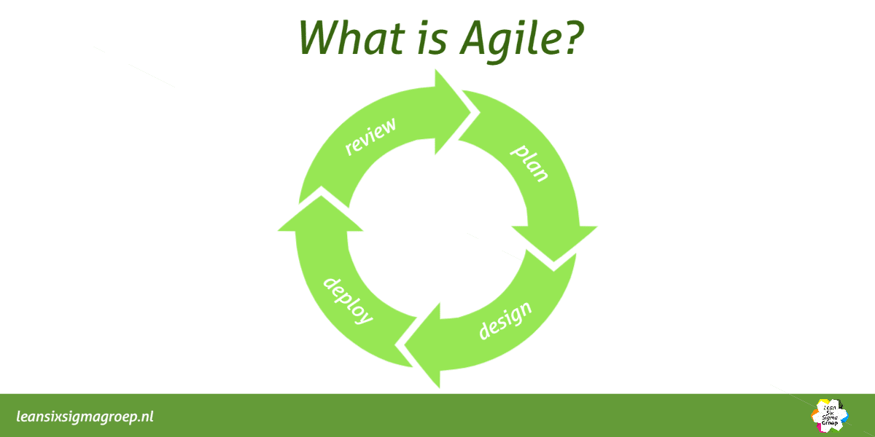

User Stories
User Need | User story | Tasks required to complete
Dangerous Links | As a user I want to be able to be able to see if a link is dangerous in an email | - Scan Email for Links  - Assess risk of link  - Give user the feedback of the links risk
Risk analysis | As a user I want to clearly know each risk score individually so I can learn the patterns | - Display the risk of the individual risks
Link Destination | As a user I always want to know where a link is heading to. | - Identify where a link destination is.
User Trust | As a user how can I be sure the risk is valid | - Use reputable databases.  - Perform rigorous testing using live phishing scams.
User control | As a user I want to have full control of what data is used and where its being sent | - Give user control on what actions are performed.
User control | As a user I want to be able to have a unique API’s so I have full control of the API used | - Allow users to provide their own API for the services they can use.
Interface | I want a simple interface that after being set up I don’t have to do anything | - Create a minimalistic Interface that after setup user no longer must interact with it.
Visual interaction | I want the information to be displayed clearly so I can understand what is happening intuitively | - Design a interactive solution that is usable by all users no matter their disability.

LESP

Legal
Phish-Hussaria will comply with all relevant privacy and data protection laws specifically targeting GDPR.
Users must know exactly what data is being analysed, how the algorithm will be processing it, and for what purpose data is used. If AI is used it will be clearly explained including whether any user data is stored or used to train future models.
All data collection and processing will be disclosed in simple language, due to the target demographic, within the EULA and Terms of Service.
Third-party API terms will always be followed to prevent any breach of their usage policies.
False positives may occur, due to this the software will include disclaimers when positive flags are identified to make it clear that final judgement rests with the user. Phish-Knight cannot be held responsible for any damages caused by user decisions or undetected phishing attempts as the final verification must lay with the user.
Copyright and patent laws will also be respected.
The architecture should remain modular so that any non-compliant or region-restricted features can be disabled depending on local laws.

Ethical
Phish-Knight is built around respecting user autonomy. The user always remains in control meaning warnings can be ignored, and the reasons for flags will always be explained. This allows users to make informed choices instead of being forced into actions by the software.
The project’s purpose is to help and educate, not to scare or pressure people. Fear-based tactics will be avoided. Instead, Phish-Knight aims to build confidence and digital awareness by showing users how to recognise phishing attempts themselves.
The software will treat all users fairly, regardless of language, demographic, or background. No user should be disadvantaged by how information is presented. The software will attempt to represent all of the above.
Where possible, human in the loop feedback will be implemented, this will hopefully let users confirm or dispute detections to help the algorithms improve over time.
Transparency and honesty are key ethical goals. Nothing about the system’s AI or data handling should be hidden, misleading or ambiguous.

Social
Phish-Knight is aimed at both elderly and younger users, particularly those who are less confident with technology. The interface will use large, readable text, clear buttons, straightforward language and it intends to have playful characteristics for children and those with a sense of humour.
The design will be culturally sensitive avoiding any colours, icons, or text that could be inappropriate or exclusionary. The tone should always remain calm, friendly, and educational.
When the software detects something suspicious, it will explain why it was flagged and what to look for next time. The goal is to teach, not shame.
Users should never feel embarrassed for being targeted instead, the software should make them feel supported and more confident online.
Phish-Knight’s visual style and mascot (a knight styled character) can reinforce this idea of friendly protection something that watches over the user without taking away their control. The reason for a knight is due to the aura of safety.

Professional
The project will follow an Agile development process for flexibility and continuous improvement. This allows me to quickly adapt to new phishing methods and release regular patches for new attack vectors.
Testing will involve real users from the target audience to ensure accessibility, readability, and ease of use. Bug testing will be frequent, with detailed crash logs to speed up fixes.
Version control will separate test builds from stable releases to keep the project organised and prevent data loss.
All testing and analytical data will be clearly disclosed, with users knowing exactly what information is being collected and why.
The EULA and TOS will be written in simple, direct language so users can understand their rights, privacy protections, and data usage without needing legal expertise.

Methodology

Programming Languages
- JS
- JSON
- Python
- HTML
- CSS

API

WHOISJSON API
Used to get information about the site such as
- Age
- Certificate
- Creation Date
- Last Updated
Which is then used to estimate the risk of the software alongside analysis of the URL.

VIRUSTOTAL API
A database that holds the risk analysis of independent organisations and user reviews for each domain name. Used to compare my results with theirs allows a wider range of results and more accurate risk score.

URL Extender & Database
My own API hosted on local machine that is used to extend any URL that has been shortened or leads to a redirect. Allows me to only view the final website the user interacts with.
Also stores and allows me to access the SQL database for all bad words to return to user. To be used in the highlighting part of the software.

MVP Metrics
- 85%<= of phishing emails flagged in test data
- >= 10% of false positives
- User feedback 90%<= find explanation clear
- Deployable to Alpha Users.
- Works for English Emails

Post MVP Expansion
- Cross browser support
- Cross Email support
- Animated Mascot
- 99%<= accuracy
- Multi-Language Supported

Risk Assessment
Risk | Likelihood | Impact | Mitigation/Response
Evolving Phishing Tactics | High | High | Software that can be easily maintained and updated to adapt to changes.
False Positives | High | High | Have a clear explanation for each flag. Provide methods to perform their own analysis if they disagree.
Data Privacy Concerns | High | Very High | Have all data processed locally where it is possible. If cloud services used or off device processing, use encrypted transmission and have a clear privacy policy
Challenges with integration | High | Medium | Start of with a small of integrated software and slowly expand the covered software.
Resource Constraints | Medium | High | Create a project schedule and keep to it. Prioritise core functions of the software. Seek feedback on development progress.
Legal Compliance and TOS | Low | High | Review GDPR and relevant regulations. Have a EULA and privacy agreement before using software.
Dependent API fail | Low | Very High | If a free and opensource API fails or stops working. Paid alternatives may be used incurring additional costs of the project and may result in an unaccounted cost for users
Misinterpretation of warnings | Low - Med | High | Use clear and non-technical vocabulary to explain warning. Possibly add More-info tab.
API limits | Medium | Very High | API calls may be limited due to not using enterprise level of software. This limits the total amount of calls I can perform daily. No Mitigation other than increasing plan at a higher cost
False Positives | Low | Very High | False positives may bring negative trust from the user for the app. However, only better algorithms can mitigate this issue.
GDPR infractions | Very Low | Very High | Ensure all data regarding users is explicitly explained in EULA minimise data used and stored.

Solution Planning and Prototyping

Process plan v1
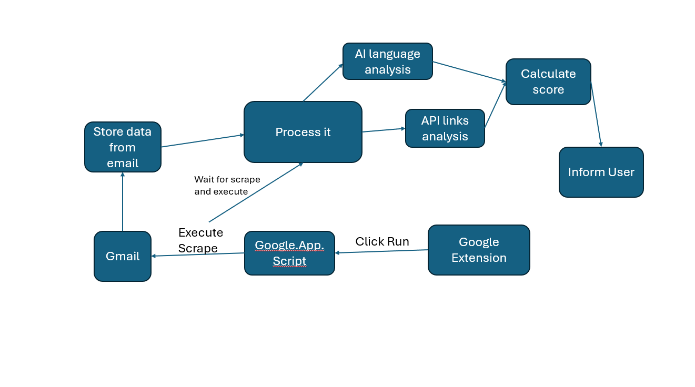
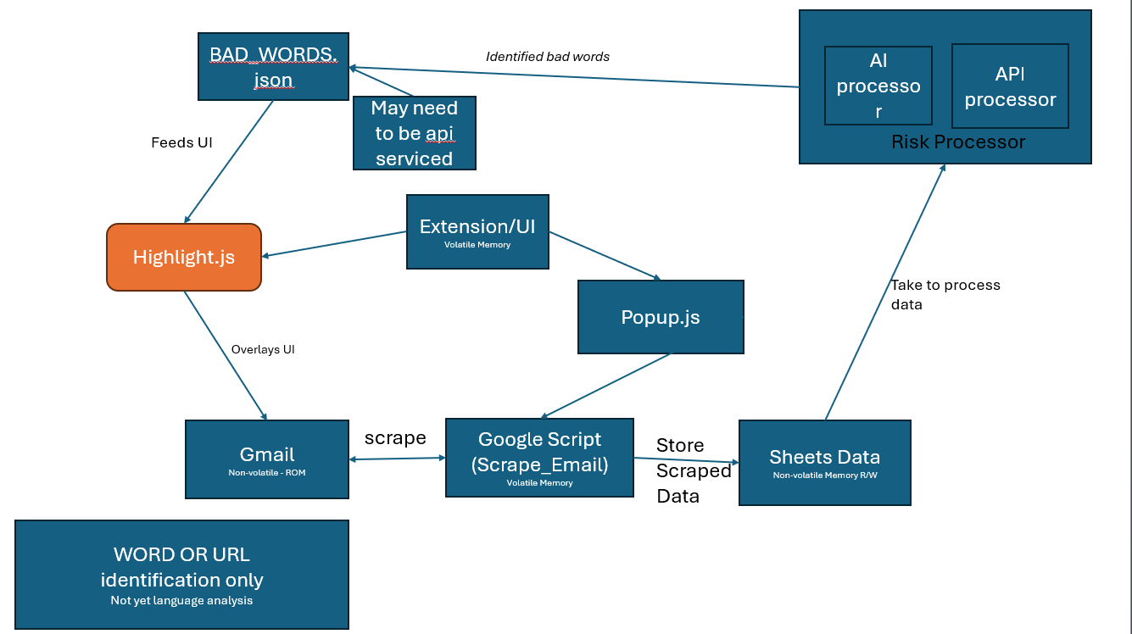
Initial estimation of how the data will be moved to perform analysis.

Process plan v2
For Words and URLS how to process the data for the user to be able to view
Chart 1:
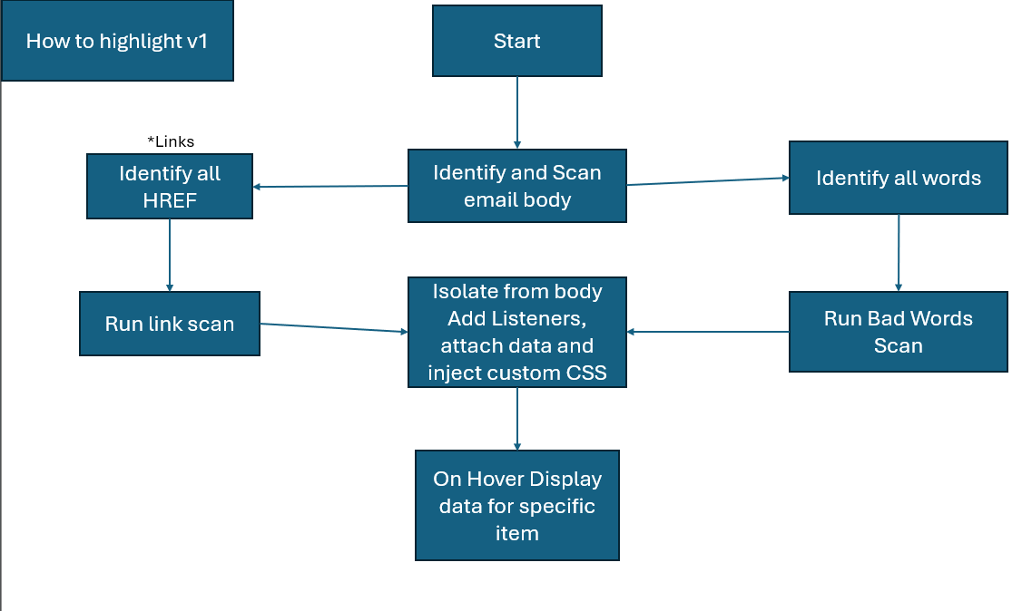

How I plan on process and reviewing the URLS to then be fed into the website this is in the “Run Link Scan” in the above (Chart 1) flow chart
Chart 2:
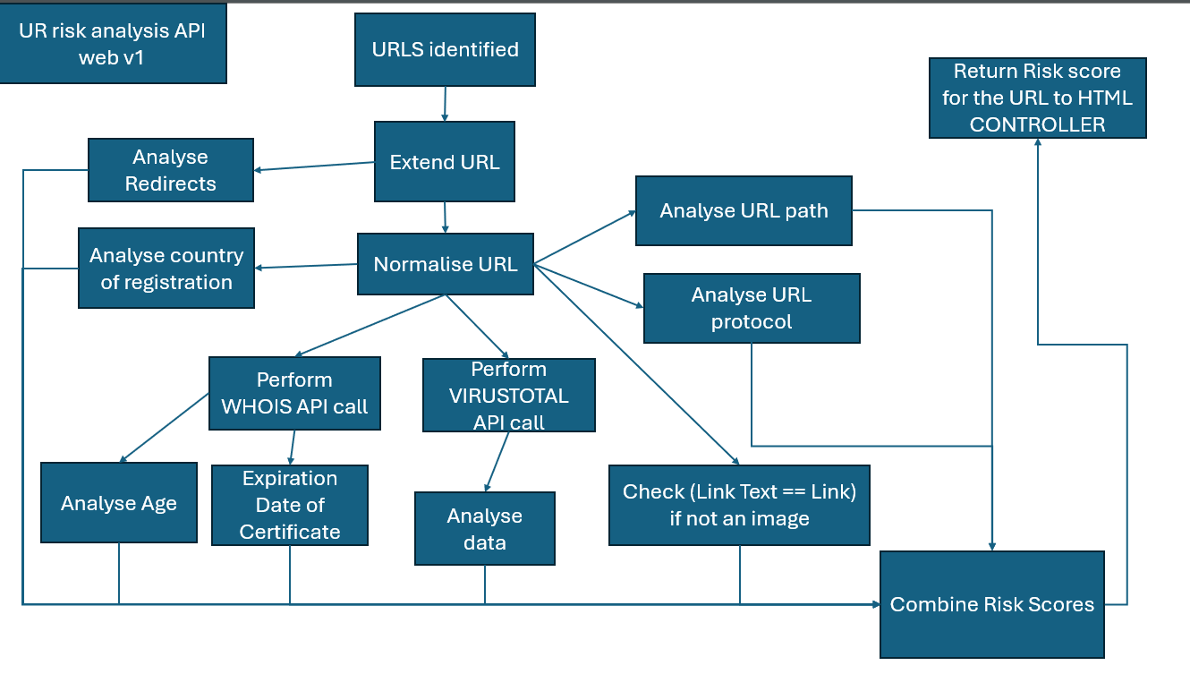
My idea of how the Highlight words would work
Chart 3:
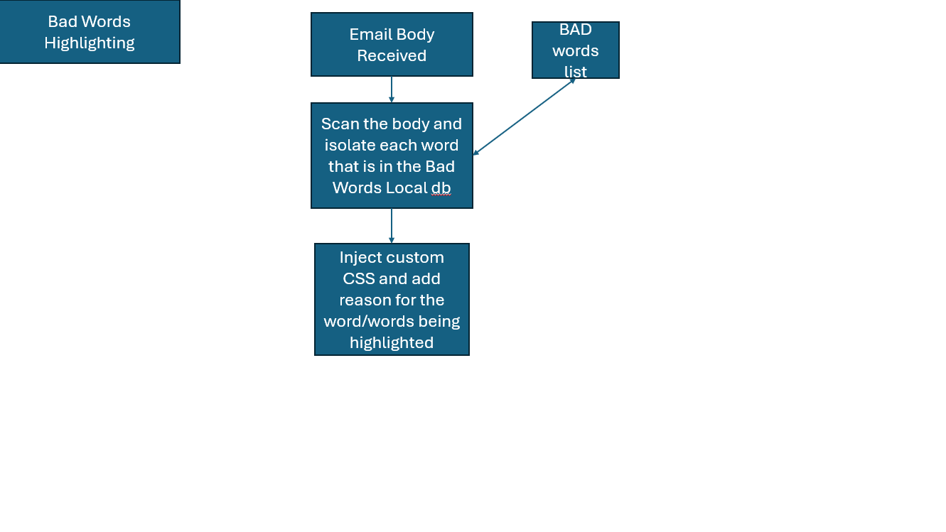

Prototype v1
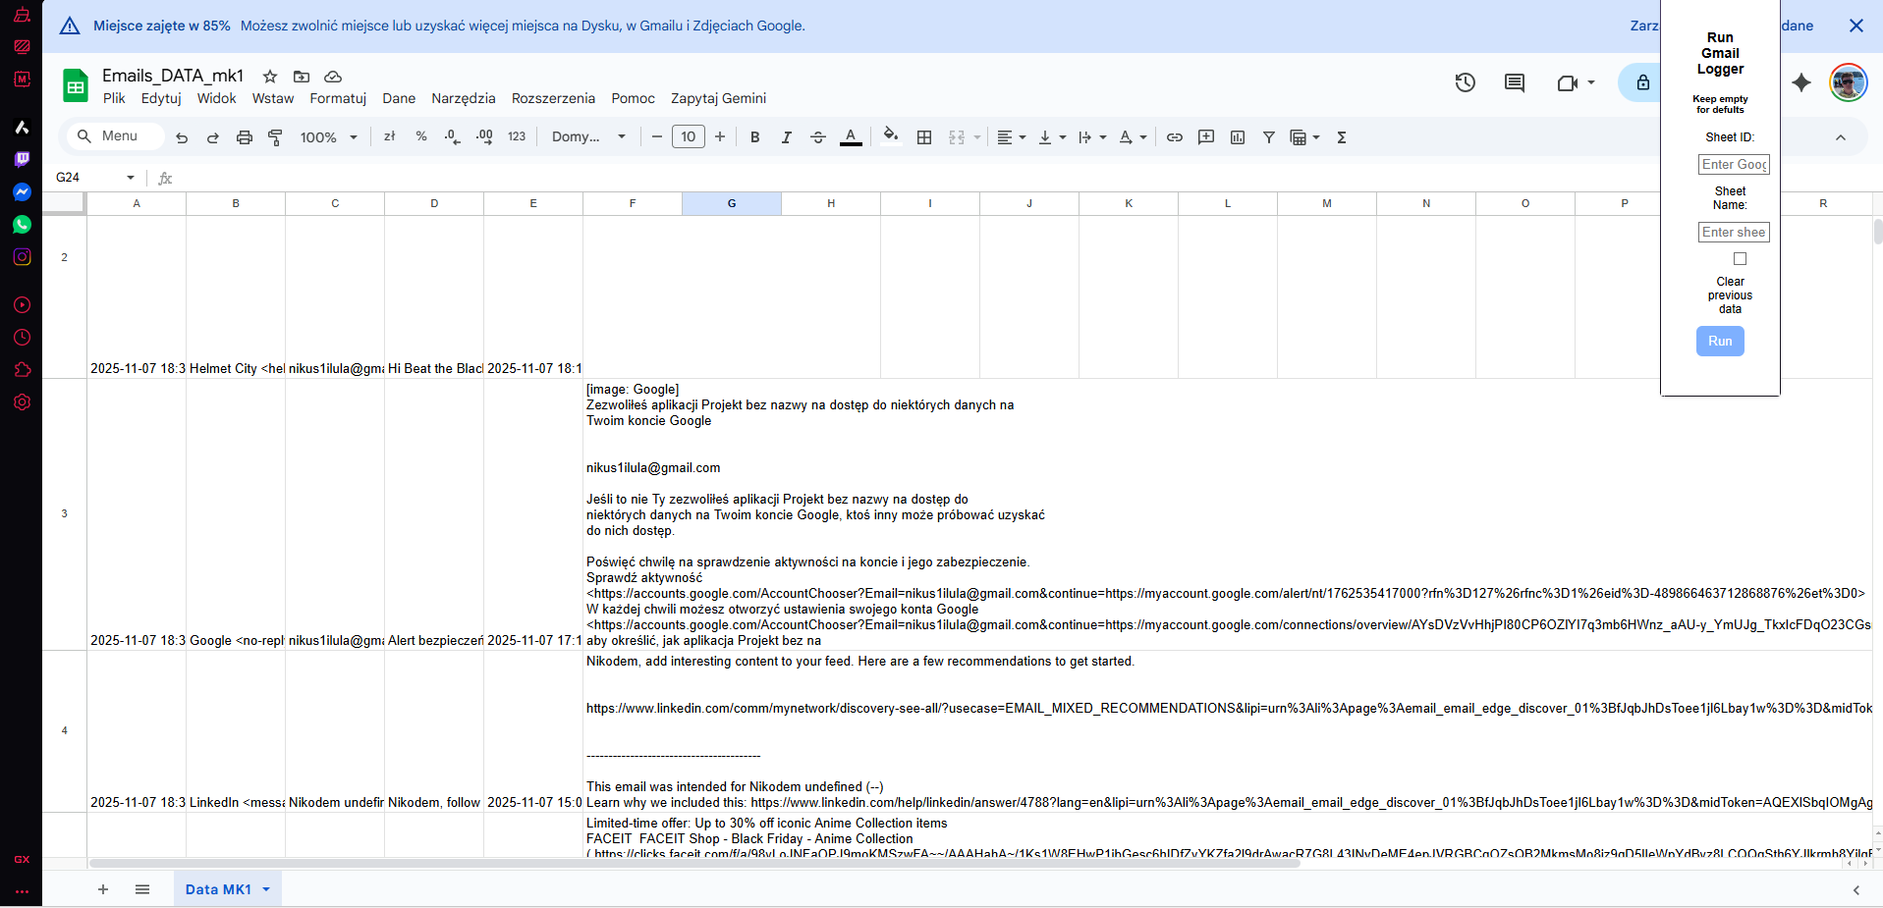
Initial prototype used the built in google ecosystem to exfiltrate the data and store as a google excel sheet. This solution required multiple steps for the user to set up and was complicated additionally it limited the final solution to be only on the google ecosystem. With the future possibilities I needed a solution that was not locked to an ecosystem.

Prototype v2

Images
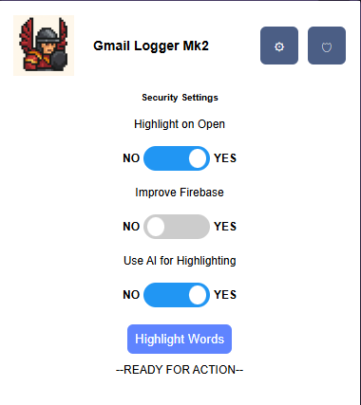
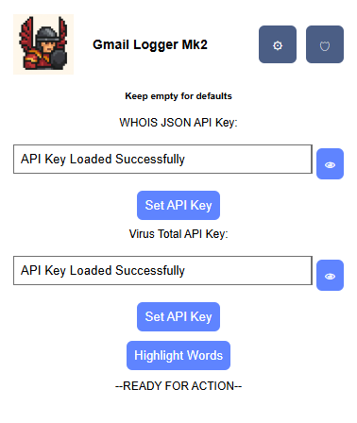
<- Settings For Api
Security Settings ->

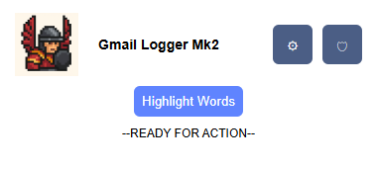

<- Extension base no expansions.

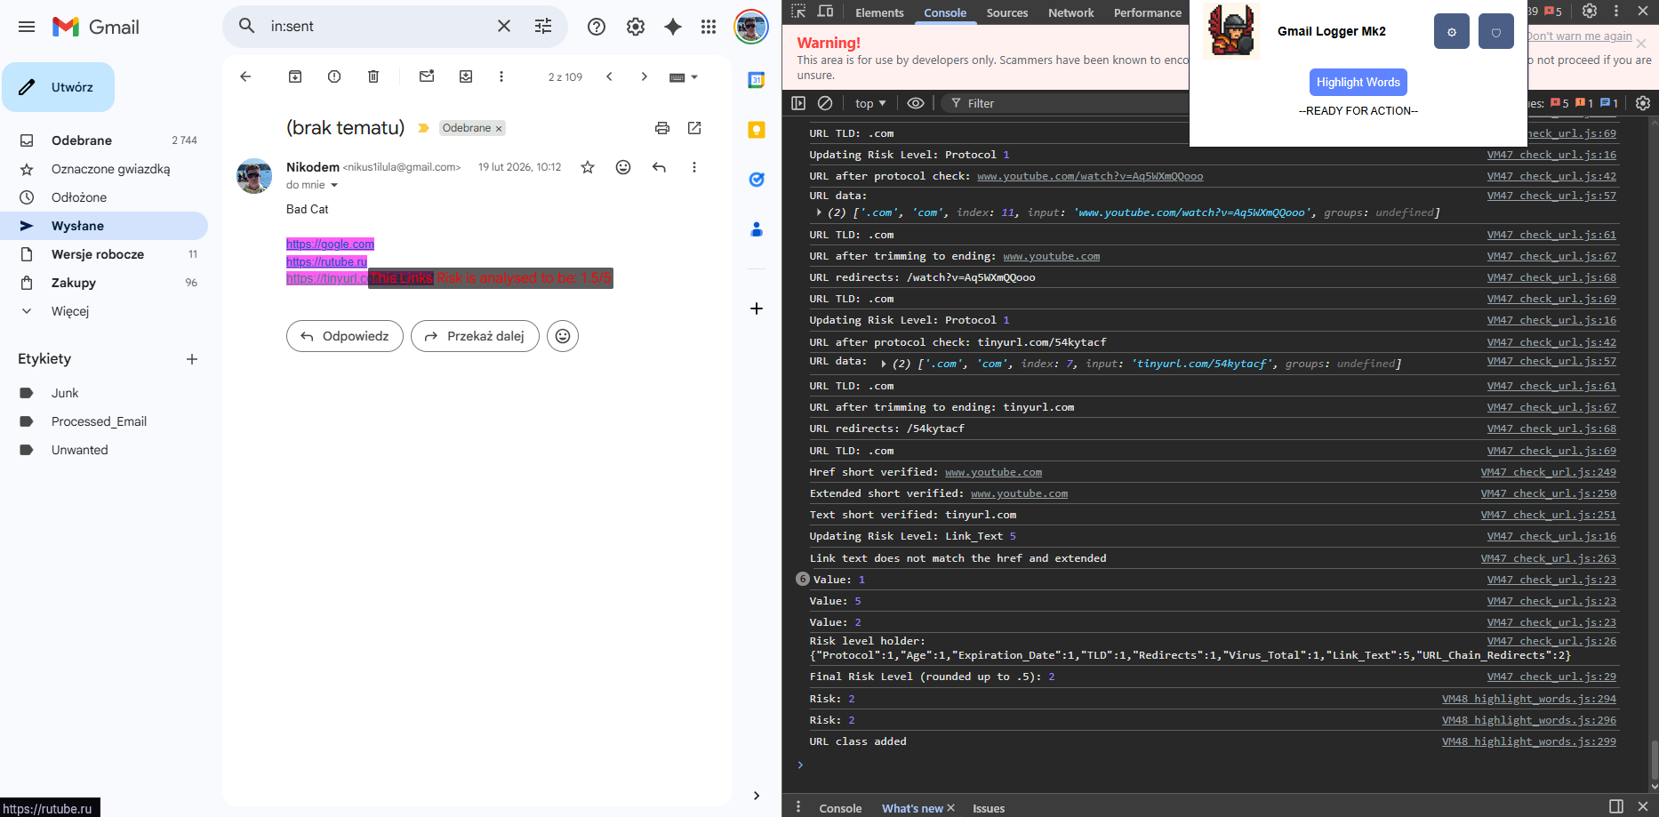
Words Highlighted in Gmail.

Changes
Created an extension that can be on any browser that uses extensions. Composes of non-ecosystem languages and tools on the backend. Improved the user setup experience. Less data is stored than before improving security.
Prototype 2 now has settings section and uses the new version of highlighting making in more contrasted. Has a rudimentary setting for security which will hold all the security controls.
API settings use chrome cookies to store the API for the user and can be viewed using the view button.
Many logic changes made to improve accuracy and added third API for highlighting bad words.

Phishing Link

GitHub
https://github.com/rf-peixoto/phishing_pot/tree/main/email
This GitHub repository contains real phishing emails that have been collected via a honeypot email address and users submitted emails. Contains real malware and links to scam websites.
This is perfect dataset to test my solution.

Analysis of dataset
Initial testing and manual review identified an issue.
Sample 408 from honey pot GitHub used LinkedIn as a median to transfer the victim.
https://www.linkedin.com/slink?code=gzq-mDRH?mwmw119300
Hence this identified for me a tactic that is being used. By re-directing to a “safe” website they mask the destination. This indicates I need to find a solution to identify final location. As a result I created an extend URL API.
Redirects to legit website to then re-direct again
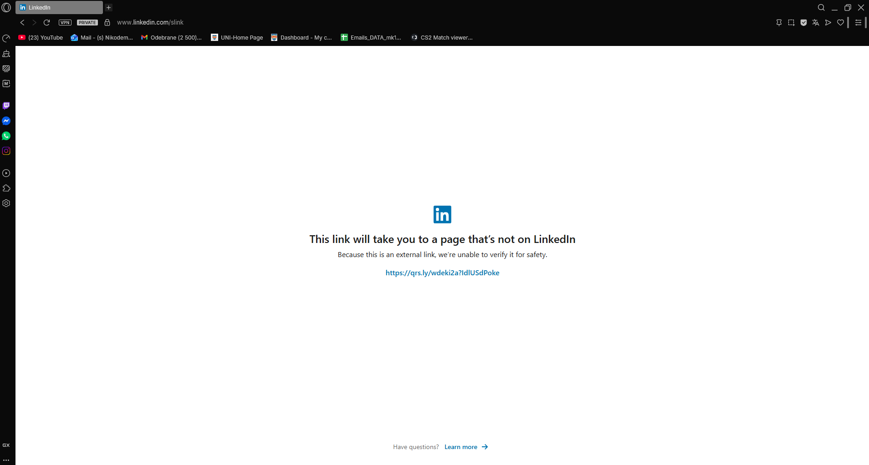
- Where it re-directed
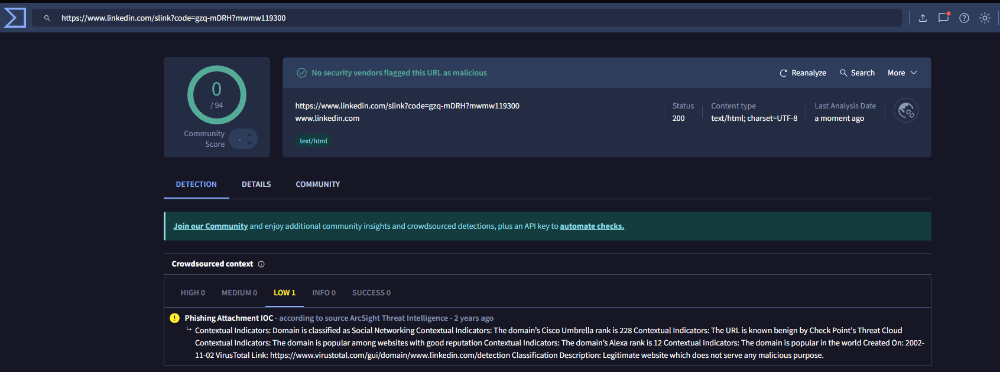
-Virus Total analysis of linked in.

Extending the URL
For this there is already an API that has been created however it could be optimised. An example is instead of getting the whole webpage I only get the header as it saves time and resources.
https://github.com/Deadpool2000/Short-URL-Expander-API/blob/main/app.py
We need to have a look to see where a link is leading too to make sure it’s safe.
- Send a get request for only the header of the destination website.
- HTTP redirects use the Location in the header to store re-direct instructions.
- If present, then the server is instructing client to go elsewhere.
- Create a loop to get header until no Location header exists indicating final location reached.
Then with the final location we do the domain analysis
Testing
Original : https://www.youtube.com/watch?v=Aq5WXmQQooo
Shorten 1 (1 redirect) : https://tinyurl.com/54kytacf
Shorten 2 (2 redirects): https://urlzs.com/4OjxlY
Get request for testing sent here:
http://localhost:5000/extend?short_url=
Outcomes are that we always stop on the original URL.

Testing

User Bias
I will likely be using the same 3 users from the majority of my non-technical user tests (users with low technical knowledge). This may result in biased results due to them gaining more knowledge about the process as it goes on and near the end of the project they may be no longer “non-technical”. As a result, I will need to take this into consideration during testing and may extend my user testing.
I have access to multiple technical users from the university, and I will use them to test the features to look for vulnerabilities and errors a non-technical user may not identify.

The users
User ID | Username | Unique Identity
User 1 | Aldona | Has limited knowledge of user interface.  Uses emails frequently at work.  Limited knowledge on Phishing scams and identifying factors
User 2 | Nicole | Some knowledge on phishing scams and technical ability.  Does not use emails for communication however uses for online stores and codes
User 3 | Marcin | Rarely uses emails other than for private official purposes and online shopping.  Limited knowledge on attacks
User 4 | Joe | Cyber Security Student.  Very Knowledgeable on the attacks and spotting attacks.
User 5 | Mark | Cyber Security Student.  Very Knowledgeable on the attacks and spotting attacks

Testing v1
I had my users my first working section of my initial prototype. I had the users test the UI for interacting with the software and tell me if the highlighting was identifiable. This test was done after my own initial agile based test and have flushed out many issues.

Function | User 1 Feedback | User 2 Feedback | User 3 Feedback
Highlighted Words.  Criteria’s:  Visible  Understand the Use | Yes, its visible  After you explained, I will be able to spot it. | Visible  No issue | Maybe issue with darker/ red background  No issue
Press Highlight  Criteria’s:  Identify the button  Press the button | I can find the button without an issue.  No issue pressing the button. I like that it changes colour. | No issue  No issue | No issue
Additional comments not related to tests | I cover a lot of my screen | I like the logo.  maybe it’s too big? | Too much boxes that I don’t need. Blocks my vision of my email.

Testing Outcome
After this test of only my highlight function, I received feedback regarding my UI and with this, I will make the following changes and additional tests.
UI:
Make the UI see-through and smaller – after testing I cannot make it transparent
Make a dedicated Settings page for additional modifiers.
Hint Box may be required to explain usability

Highlight_Words:
Test with different backgrounds of text as red colour may affect it.

Testing action taken
After Looking at the comments, I went and noticed that it would be useful to also add a secondary section for Security Safety now, so the UI is ready for the future.
After the testing outcomes I went back to the design elements of my UI. My initial design had flaws and here are the steps I took to develop a better UI and improve the UX. I attempted to make the Extension see through I used google documentation and stack overflow however this is not possible in google as the extension is classed as its own app and has a forced white background. So the final changes were:

UI:
I made the UI smaller and relocated the additional settings to the to a separate tab that is a small cog.
I redesigned the sizing of sections so that the UI is more compact. The aim is that it will take up much less space than before
I made the red less of a dark red due to it making it difficult to see for the user. This may indicate that it was not visible to users with colour identification impairment specifically Protanopia (red colour deficient).

Sprints
Sprint Date – The time the sprint was performed
Format: Month / Week of the month 1-4
Objectives – The aims of the sprint
Achieved & TBD – The achieved objectives and from that sprint any new discoveries and items “to be done” (TBD)
Achieved
To Be Done
SPRINT DATE | OBJECTIVES | ACHIEVED & TBD
10/W2 – 11/W2 | Planning and research of project learning different possible solutions | Market research  Project Idea  Software solutions
11/W1 11/W3 | Experiment with the possible solutions begin prototyping | Created an email scraper using google online software.  Store emails in the users google spreadsheets.  UI is implemented partially has working buttons and scrapes emails. Added settings to choose how long back to scrape and how many emails to scrape at one time.  Identified issues where the software scraping is limited by the ecosystem. Difficult to set up.
11/W4 12/W2 | Change from google script to full JS on the extension side | Ported scraper to use JS to read the HTML and identify body of email. Scrape the email and inject CSS to be able to highlight the words. Added code to view Risk on Hover of the highlighted word/link.  Implemented a variety of pre-determined reasons for warnings to be displayed for the user so they learn.
12/W2 1/W1 | Documentation period and testing period of current prototype. Additionally, study on different coursework no valuable coding done. | Testing and feedback on first UI changes to improve the work.
1/w2 1/w4 | Implement code to scan URLS provide risk score and use API’s to be able to gather additional URLS | Code now isolates URLS to scan them and use WHO IS API and VirusTotal database to gain additional data regarding URL. Implemented my own risk analysis score and used the other databases to verify my own research. Testing highlighted the use of URL redirects. Now need to implement URL extenders.
2/w1/ 2/w2 | Implement URL extender API. | Created my own API that can be called to extend any URL and identify its destination using header.  Added ability to query the database using API to get bad words that are in the email. Partially works needs more work.  Ran usability tests and identified issues that need to be fixed.
2/W3 3/W1 | Documentation and other CW | PowerPoint and Main documentation work updated.

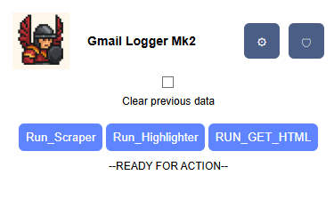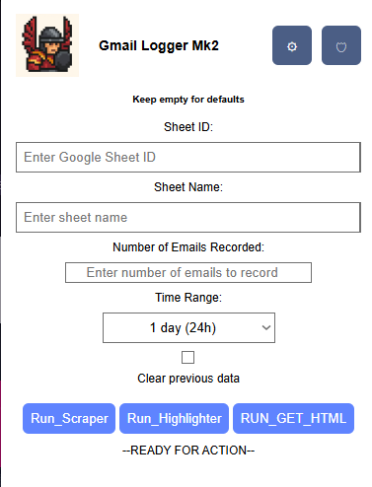

References
[1] Government of the UK (2025) Cyber security breaches survey 2025, GOV.UK. Available at: https://www.gov.uk/government/statistics/cyber-security-breaches-survey-2025/cyber-security-breaches-survey-2025.
‌

